Test 6 - Beta Version of an Intelligence Test

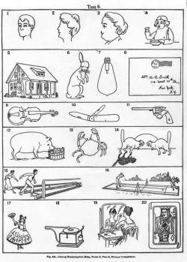

Test 6 - Beta Version of an Intelligence Test
This is the Beta version of the Stanford-Binet intelligence test, which was created by Lewis Terman, a professor of education at Stanford University. The purpose of the Alpha and Beta versions of the test in 1917 was to determine which of the recent military draftees in the United States were candidates for officer training and which were unfit for service. The Beta test was intended for illiterate draftees. In the test, each picture has a part missing, and the test taker was to identify the missing part in as many pictures as possible within three minutes.

CREDIT LINE
Memoirs of the Nations Academy of Sciences, vol. XV, "Psychological Examining in the United States Army," Washington: GPO, 1921.

