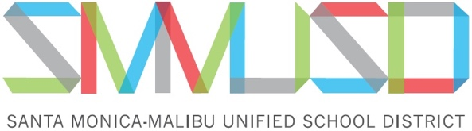

Edison Language Academy Scholarship Application

The Edison Academy will be giving scholarships to graduating Samohi Immersion Student who participated in the Immersion Program K-12.

Requirements

The Immersion Student must:
- be an eligible Immersion student who is an Edison Alumni.
- plan to attend college.
- have a 2.75 GPA or above.
- write 2 short essays, one in Spanish and one in English.

Please choose two (2) different topics to write about, One essay in Spanish and one essay in English (300-500 words each).

- What are your future plans upon graduating from Samohi and how has your participation in the Immersion program influenced those plans?

- Why do you think being bilingual/biliterate is important?

- How has participating in the Immersion Program broadened your understanding of your culture and/or the culture of others?

If you have any questions please contact
Claudia Bautista-Nicholas at extension 71305 or cbautista@smmusd.org

Please turn in Scholarship Application and Essays to Mrs. Bautista (I305)

NO LATER than Friday, May 24th, 2019

Scholarship recipient(s) will be announced at the
Saturday, June 8, 2018, 11:30-2:00 PM
Immersion Graduation Celebration at Edison Language Academy

Edison Language Academy Scholarship Application

Name: _________________________________________________________________________________

Dates attended Edison Language Academy: ___________________________________________________

College you will attend in 2019-2020: ________________________________________________________

What is your graduating GPA: ______________________________________________________________

Requirement

Please choose two (2) different topics to write about, One essay in Spanish and one essay in English (300-500 words each).

- What are your future plans upon graduating from Samohi and how has your participation in the Immersion program influenced those plans?

- Why do you think being bilingual/biliterate is important?

- How has participating in the Immersion Program broadened your understanding of your culture and/or the culture of others?

If you have any questions please contact
Aida Diaz at (310) 450-8338 Ext. 70331 or at adiaz@smmusd.org

Please turn in Scholarship Application and Essays to Mrs. Bautista (I305)

NO LATER than 3:15 Friday, May 24th, 2019

Scholarship recipient(s) will be announced at the
Saturday, June 8, 2019
Immersion Graduation Celebration at Edison Language Academy

